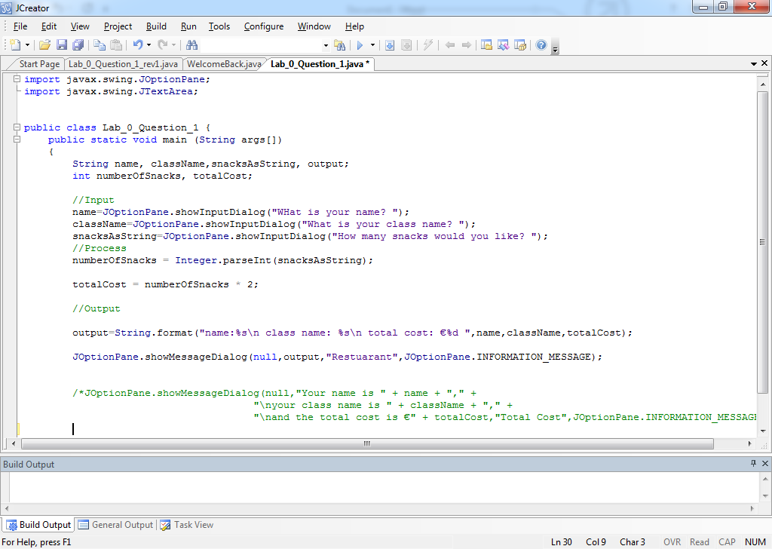

Assigning Values

Local Variables

Method Header

Class Header

Import statements